Information day on Wednesday 13th April at the Portaferry Hotel 11 -6pm.

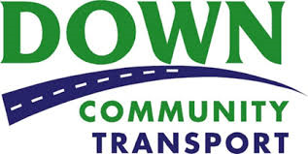
Do you live in a rural area?
Do you have difficulty getting to appointments, shops, visiting friends/family or recreational activities?
If yes, WE CAN HELP!
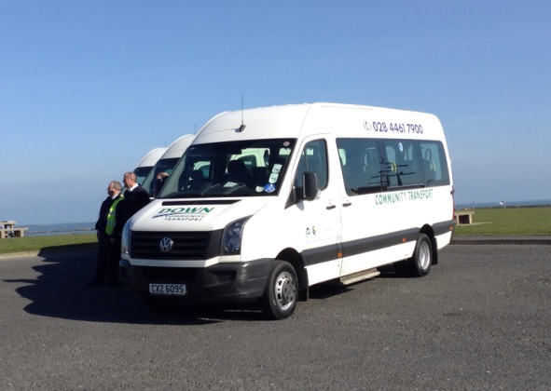

We can collect you in our minibuses, or if you're travelling further afield you can avail of our social car driver scheme.
For more information on how we can help with your transport needs, and to register for this scheme contact:
Down Community Transport on 02844 617900

