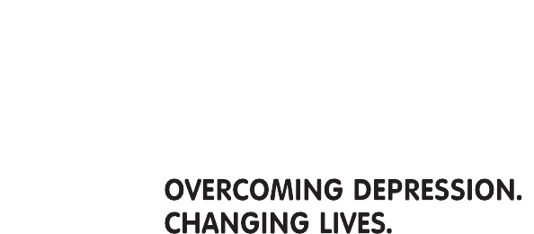
Support

Group
How does depression
affect you?

At Ards Community Network Centre, 43-45 Frances Street, Ards.

Depression affects 1 in 4 people during their lifetime.
Find out what you can do to help yourself or people close to you.

AWARE is opening a new Support Group in Ards on a Wednesday evening from 7.00-8.30pm (Fortnightly). We welcome people experiencing depression and their friends and family. Opens on Wednesday 6th April.
This is free of charge and anyone is welcome to attend.
For more information visit www.aware-ni.org or call our helpline on 08451 20 29 61.

